Project Design Phase-II
Data Flow Diagram & User Stories
Date | 03 October 2022
Team ID | PNT2022TMID17856
Project Name | Project - Estimate the crop yield using data analytics
Maximum Marks | 4 Marks
User Stories
Use the below template to list all the user stories for the product.
User Type | Functional Requirement (Epic) | User Story Number | User Story / Task | Acceptance criteria | Priority | Release
Customer(Web user) | Registration | USN-1 | As a user, I can register for the application by entering my email, password, and confirming my password. | I can access my account / dashboard | High | Sprint-1
 |  | USN-2 | As a user, I will receive confirmation email once I have registered for the application | I can receive confirmation email & click confirm | High | Sprint-1
 |  | USN-3 | As a user, I can register for the application. | I can register & access the dashboard | Low | Sprint-2
 |  | USN-4 | As a user, I can register for the application through Gmail | Succesfully Registered | Medium | Sprint-1
 | Login | USN-5 | As a user, I can log into the application by entering email & password | Successfully Login | High | Sprint-1
 | Dashboard | USN-6 | As a user, I can access the dashboard. | I can enter the Value in dashboard. | High
 | Analysis | USN-7 | As, a user I can analyze the crop | estimation of crop | High
Administrator | Managing all the Users. | USN-8 | As a administrator, I can access the database | add,delete or update the users information. | High

Data Flow Diagram for Crop Yield Estimation:

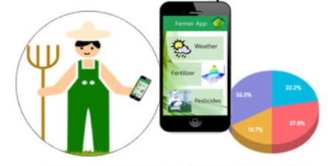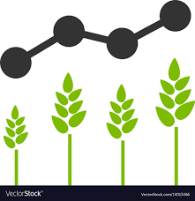
Data analysis
Consumer(Farmers)

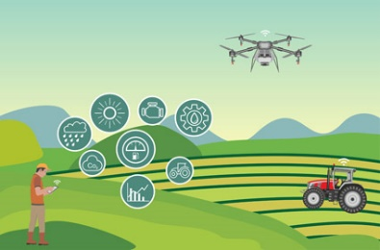
Get crop details from the user

